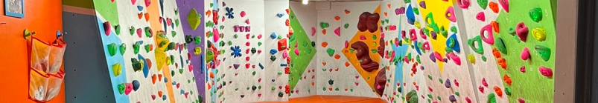  You are Invited to a birthday party for  ................................    at  on ............ ..................................  at ........pm  _____________________________  Directions to Climb Newcastle:  The centre is located in the Old Byker swimming pool, adjacent to Byker Metro Station. From Shields Road in Byker travelling away from Morrisons, go through 1st set of lights and turn right at 2nd. Follow the road passing the Job Centre and Metro station to a T-junction. Turn right and immediately left into the car park or park on the road further along.  Address: Shipley Place, Byker. NE6 2DQ (parking at rear of building on Conyer's Road) | You are Invited to a birthday party for  ................................  at  on ............ ..................................  at ........pm  _____________________________  Directions to Climb Newcastle:  The centre is located in the Old Byker swimming pool, adjacent to Byker Metro Station. From Shields Road in Byker travelling away from Morrisons, go through 1st set of lights and turn right at 2nd. Follow the road passing the Job Centre and Metro station to a T-junction. Turn right and immediately left into the car park or park on the road further along.  Address: Shipley Place, Byker. NE6 2DQ (parking at rear of building on Conyer's Road)
You are Invited to a birthday party for  ................................  at  on ............ ..................................  at ........pm  _____________________________  Directions to Climb Newcastle:  The centre is located in the Old Byker swimming pool, adjacent to Byker Metro Station. From Shields Road in Byker travelling away from Morrisons, go through 1st set of lights and turn right at 2nd. Follow the road passing the Job Centre and Metro station to a T-junction. Turn right and immediately left into the car park or park on the road further along.  Address: Shipley Place, Byker. NE6 2DQ (parking at rear of building on Conyer's Road) | You are Invited to a birthday party for  ................................  at  on ............ ..................................  at ........pm  _____________________________  Directions to Climb Newcastle:  The centre is located in the Old Byker swimming pool, adjacent to Byker Metro Station. From Shields Road in Byker travelling away from Morrisons, go through 1st set of lights and turn right at 2nd. Follow the road passing the Job Centre and Metro station to a T-junction. Turn right and immediately left into the car park or park on the road further along.  Address: Shipley Place, Byker. NE6 2DQ (parking at rear of building on Conyer's Road)

